ISTANBUL TECHNICAL UNIVERSITY

COMPUTER ENGINEERING DEPARTMENT

BLG 546E
OBJECT ORIENTED CONCURRENT PROGRAMMING

CRN: 23438
Instructor: Tolga Ovatman

Report of Homework #3
April 29, 2018

Tuğrul Yatağan
504161551

Development, Build and Test Environment
Ubuntu 16.04.4 LTS Linux kernel 4.4.0-116-generic is used for build and test environment. Test system has 6 GB of RAM and 8 core i7-3632QM 2.20 GHz CPU. Oracla Java 8 is used for Java virtual machine. Following commands is used for installing Java virtual machine and IntelliJ IDEA:
sudo add-apt-repository ppa:webupd8team/java
sudo apt install oracle-java8-installer
sudo snap install intellij-idea-community -classic

Java VM Options: -Xmx4g -Xss256m
Example screen shot of development environment:
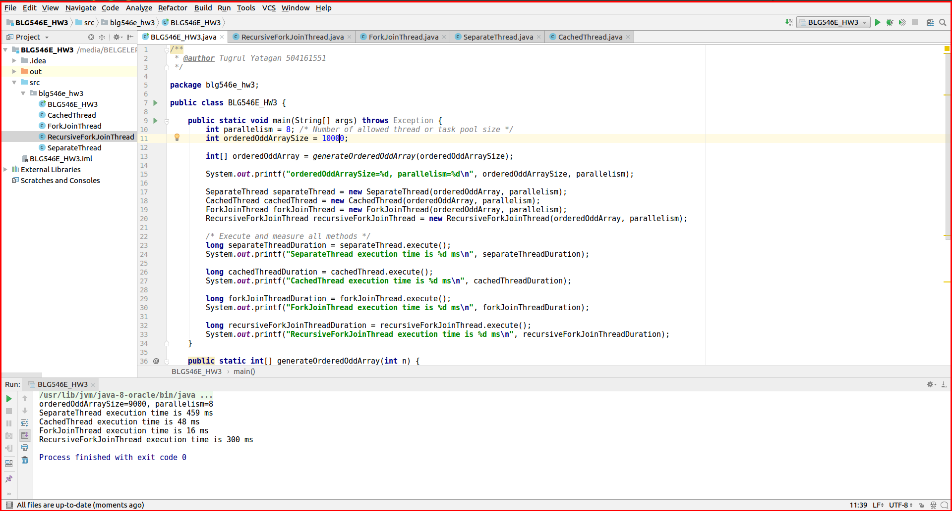
Example output:
Application is run with;
- Different concurrency methods;
  - SeparateThread
  - CachedThread
  - CachedThread
  - RecursiveForkJoinThread
- Different array size parameters;
  - 10K
  - 100K
  - 1M
- Different thread or task pool size;
  - 8
  - 16
  - 32

N=10K
orderedOddArraySize=10000, parallelism=8
SeparateThread execution time is 509 ms
CachedThread execution time is 51 ms
ForkJoinThread execution time is 26 ms
RecursiveForkJoinThread execution time is 393 ms

orderedOddArraySize=10000, parallelism=16
SeparateThread execution time is 510 ms
CachedThread execution time is 49 ms
ForkJoinThread execution time is 22 ms
RecursiveForkJoinThread execution time is 386 ms

orderedOddArraySize=10000, parallelism=32
SeparateThread execution time is 502 ms
CachedThread execution time is 38 ms
ForkJoinThread execution time is 26 ms
RecursiveForkJoinThread execution time is 364 ms

N=100K
orderedOddArraySize=100000, parallelism=8
SeparateThread execution time is 3879 ms
CachedThread execution time is 144 ms
ForkJoinThread execution time is 91 ms

orderedOddArraySize=100000, parallelism=16
SeparateThread execution time is 3786 ms
CachedThread execution time is 145 ms
ForkJoinThread execution time is 67 ms

orderedOddArraySize=100000, parallelism=32
SeparateThread execution time is 3826 ms
CachedThread execution time is 158 ms
ForkJoinThread execution time is 70 ms

N=1M
orderedOddArraySize=1000000, parallelism=8
SeparateThread execution time is 35075 ms
CachedThread execution time is 1158 ms
ForkJoinThread execution time is 379 ms

orderedOddArraySize=1000000, parallelism=16
SeparateThread execution time is 35927 ms
CachedThread execution time is 1095 ms
ForkJoinThread execution time is 449 ms

orderedOddArraySize=1000000, parallelism=32
SeparateThread execution time is 34989 ms
CachedThread execution time is 1124 ms
ForkJoinThread execution time is 687 ms

Test Results
Execution time for SeparateThread, CachedThread, ForkJoinThread and RecursiveForkJoinThread methods are put in a chart.
Execution results shows that, ForkJoinThread performs best and SeparateThread method performs worst. Execution time for SeparateThread method increases drastically while array size increases. CachedThread and ForkJoinThread performs relatively well while array size increases thus CachedThread and ForkJoinThread are more scalable solution.
Thread or task pool size (parallelism factor) has no or very little effect on overall performance.

